Engineering Journal : Yarara Team Future Engineers category WRO2023 Argentina

***Participants****: Zayas Ana Florencia, Aguirre Franco Joaquin*

***Mentor****: Juan Jose Campis*

***Country:*** *Argentina*

This is the engineering journal of the Yarará Team, proudly representing Argentina in the WRO Panama 2023 competition. Our team consists of two dedicated students and a mentor. Hailing from the province of Misiones in the northwest of Argentina, we started our journey into the world of robotics through the ERM (Escuela de Robótica Misiones).Which is an after-school program that passionately nurtures young minds in the realms of electronics, programming, and design.

**Mobility Management**

As the regulations for the competition say, we use one dc motor and one servo motor on our robot. In order to make the steering system work, we attached a 3d printed piece which allows both front wheels to move from left to right.This system is pretty simple. However we consider it to be useful. As regards to the dc motor , we attached two wheels to the motor, that way we could make our robot way more efficient and compact.The dc motor (which is in the rear of the chassis) allows the robot to move forward and back.

**Power and Sense Management**

We took the decision to power the circuit using two batteries; one for the logical part (like the raspberry and the camera) and the other that powers the dc motor. The camera is connected to the raspberry pi while the ultrasound sensors are connected to the arduino.

We decided on the HC SR-04 sensors since we are familiarized with them when it comes to coding but we intend to use more precise sensors soon.

| **description** | **we used** | **we intend to use** | **quantity** |
| --- | --- | --- | --- |
| Controller board | nano / ESP32 - 8266 / Pico | ESP32 / ESP8266 | 1 |
| Driver Motor | TB6612 / L298n / L293D | Breakout ESP32 + L293D | 1 |
| Servo Motor | SG90 / MG90S | MG90S | 1 |
| DC Motor w/ wheels | Plastic dc motor | caja reduc azul (metal) | 1 |
| Proximity sensors | HC SR-04 | TOF 400C | 3 |
| For color detection | TCS3200 / rpi cam | rpi cam | 1 |
| SBC | Rpi zero w / Rpi 4 | Raspberry pi 4 | 1 |
| Batteries | Li-po | Li-po | 2 |
| jumpers/wires | Generic | Generic | X |
| switch | Generic | Generic | 2 |
| Li-po chargers | Generic | Generic | 3 |
| gyroscope | MPU6050 | MPU6050 | 3 |

**Obstacle Management**

**Pictures – Team and vehicle**

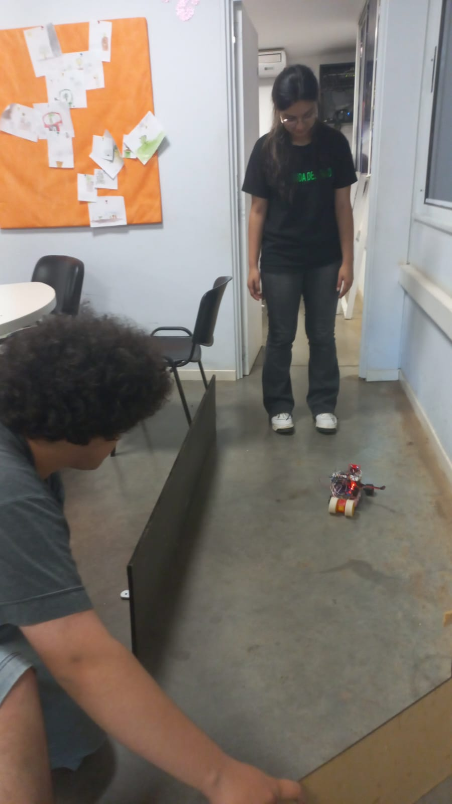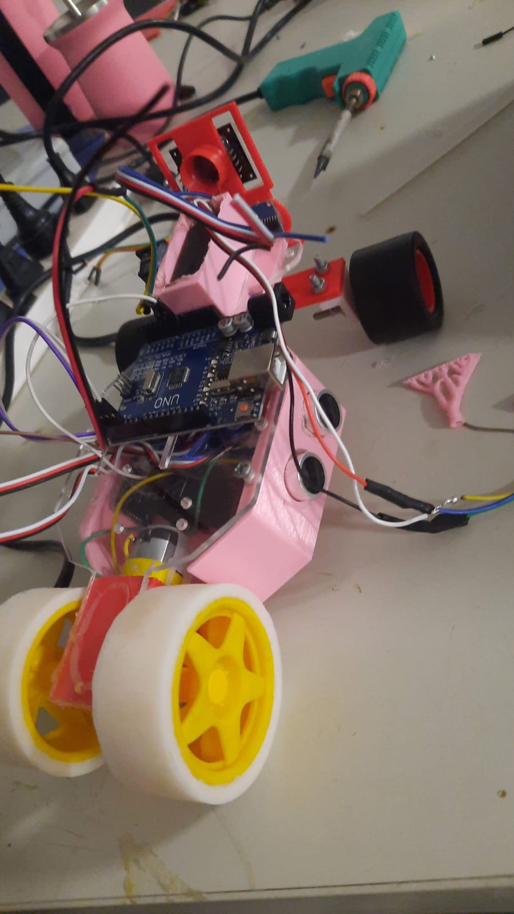

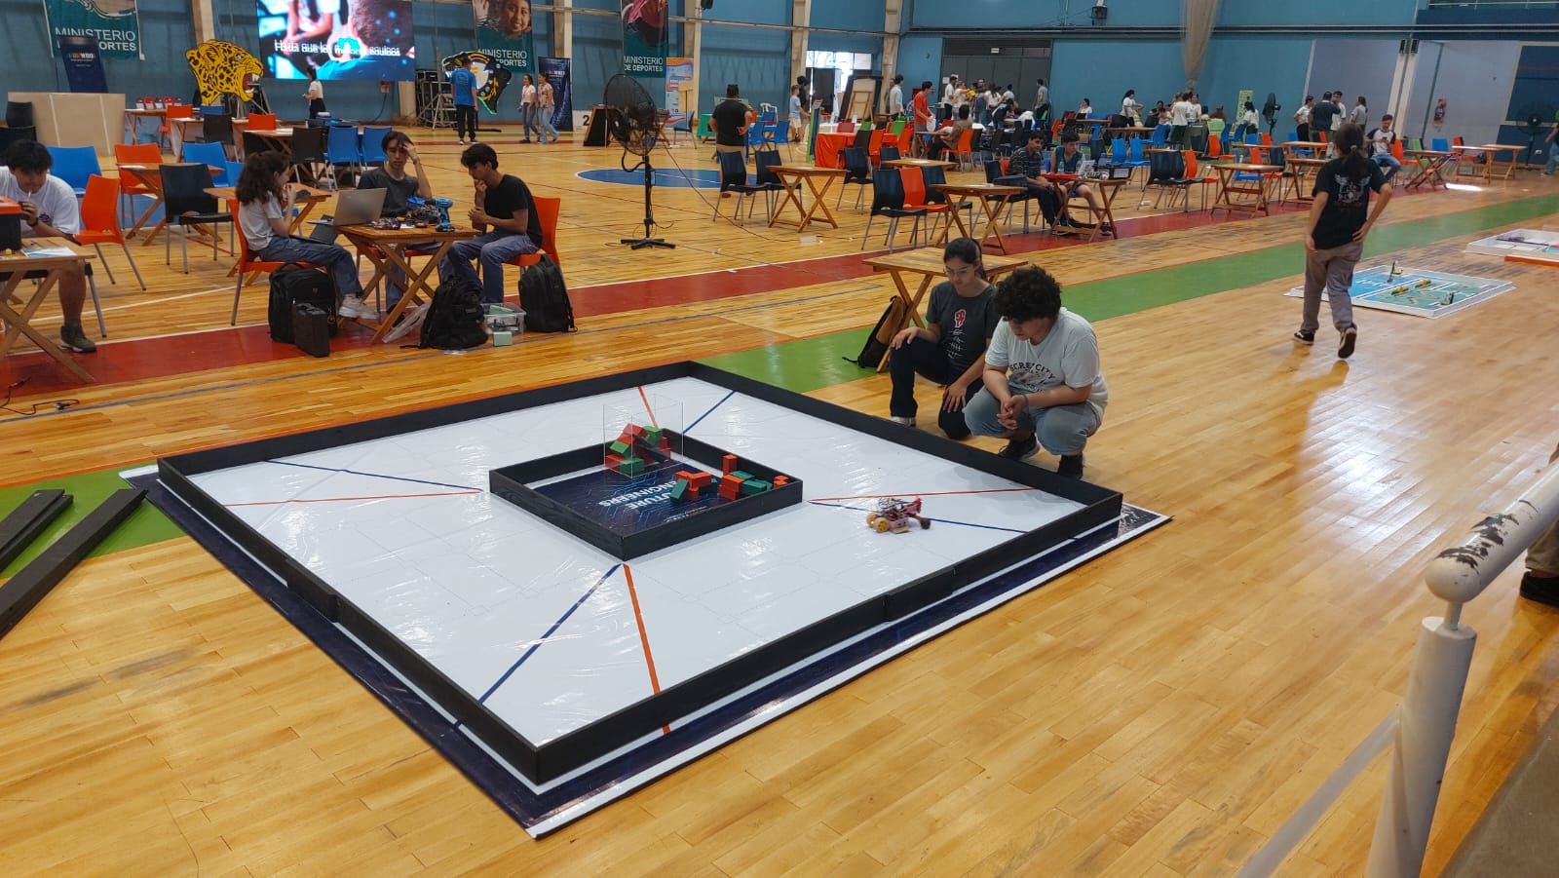

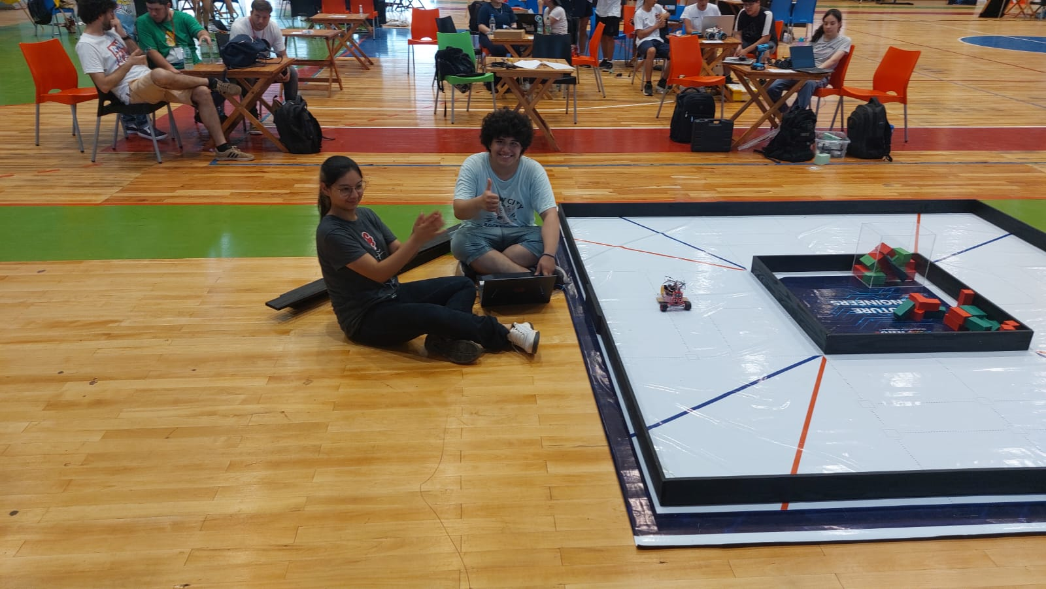

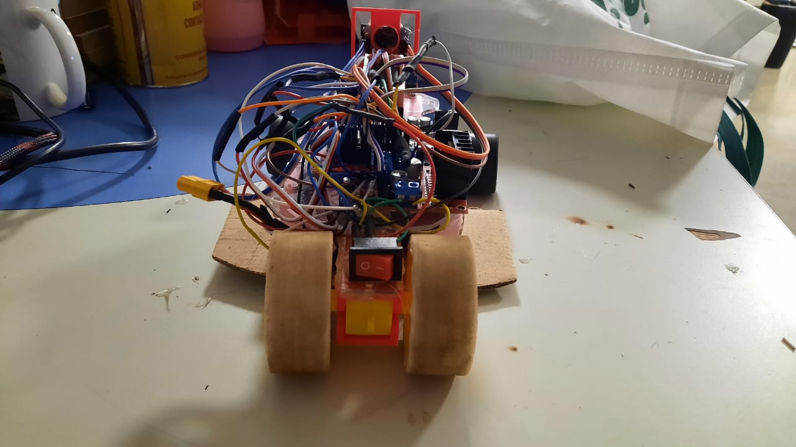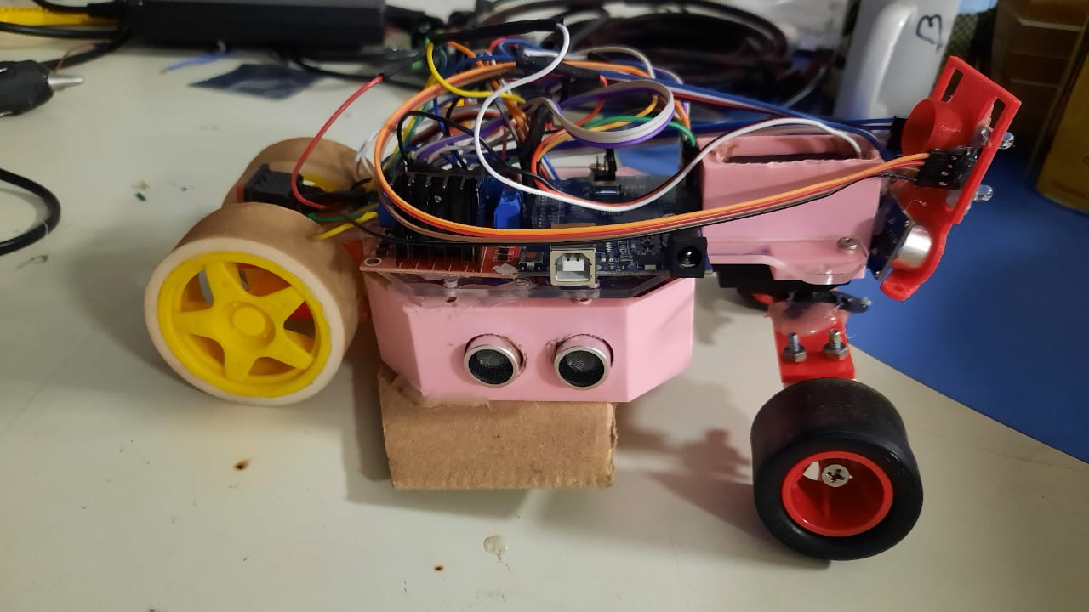

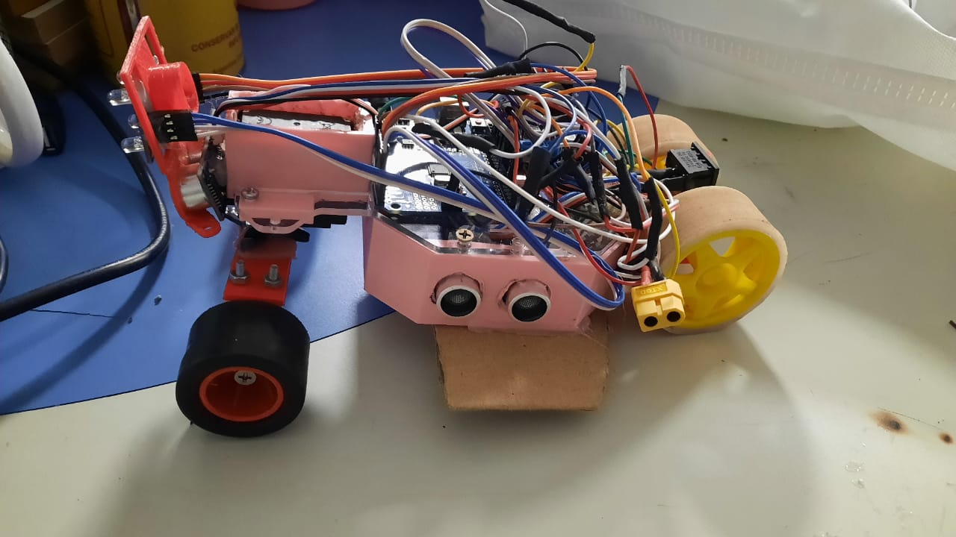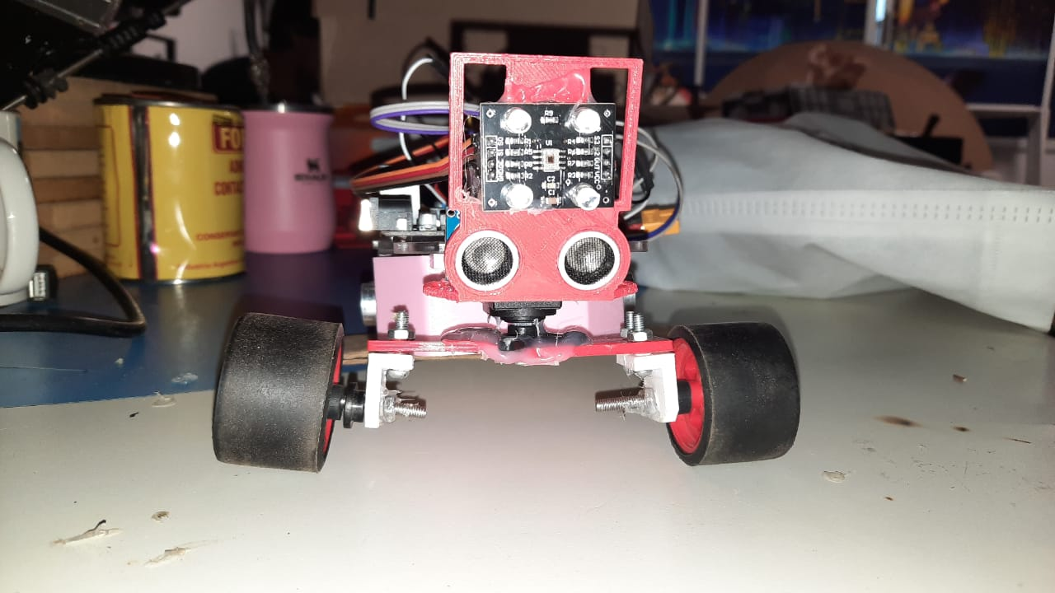

**Engineering Factor**

Since this is our first time participating in the WRO, we weren't quite sure how to face this competition. We put together the components for our robots by taking into account our previous experiences using them.For example, we used an arduino uno for our first prototype which we are very familiar with, as well as, the so-called “yellow plastic gearmotor”.